Identifying Poisonous Plastics
Written by C. Thomas Corriher
This article summarizes the dangers of plastic bottle containers, which we typically assume are safe to eat and drink from. It explains the symbols found on plastic containers, which is useful for identifying the different types of poisons that are leached from them -- from arsenic to petroleum. Plainly labeled on the underside of plastic containers is a number indicating the type of plastic used.
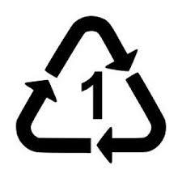
Plastic Identifier: #1 or PET
PET is a plastic that is sometimes distinguished by a #1 stamp. PET is an abbreviation for polyethylene terephthalate. It releases a chemical named antimony trioxide. This chemical toxin has been cited many times as a serious health concern, yet these concerns have been discarded by governments, who have claimed that not enough of this chemical is released to cause problems.
Plastic Identifier: #2 or HDPE
HDPE is identified by a #2 stamp. HDPE stands for high density polyethylene, which is a thermoplastic made from petroleum. This is the safest plastic available, because it is very non-reactive.
Plastic Identifier: #3 or PVC
This plastic is one of the most hazardous. Poisonous chemicals are released throughout the life cycle of PVC, including mercury, dioxins, and phthalates. When people burn PVC products, they release dioxins producing cancers, respiratory, and reproductive problems. The fumes can cripple the immune system for years. The noticeable smell from a new car or shower curtain is the result of PVC fumes.
In July 2005, the European Parliament banned the use of PVC toys, although they are still legal in America. This material is also used in drinking bottles, and therefore, toxins are inside most bottled drinks. Factory workers who work with these materials face long-term health risks, including angiosarcoma of the liver, lung cancer, brain cancer, lymphomas, leukemia, and liver cirrhosis. Firefighters also often face similar risks after extinguishing PVC fires, which release hydrogen chloride gas, which forms deadly hydrochloric acid when inhaled.
PVC is not recyclable due to its extremely toxic properties. It is known to leach its poisonous chemicals into drink containers.
Plastic Identifier: #4 or LDPE
LDPE is the abbreviation for Low Density Polyethylene. It is virtually identical to HDPE (reference #2 above).
Plastic Identifier: #5 or Polystyrene
This is one of the safer plastics, but safe is a relative term. Since it is manufactured with benzene and petroleum, we recommend avoiding it. Styrene is itself a carcinogen.
Plastic Identifier: #7 or Other
The "other" literally means unspecified and uncategorized. This plastic could be made from anything, so always avoid these plastics. It is very common for these plastics to contain BPA.

Seoul authorities find toxic substances in Shein and Temu products
August 21, 2024 7:04 AM
- By Agence France-Presse

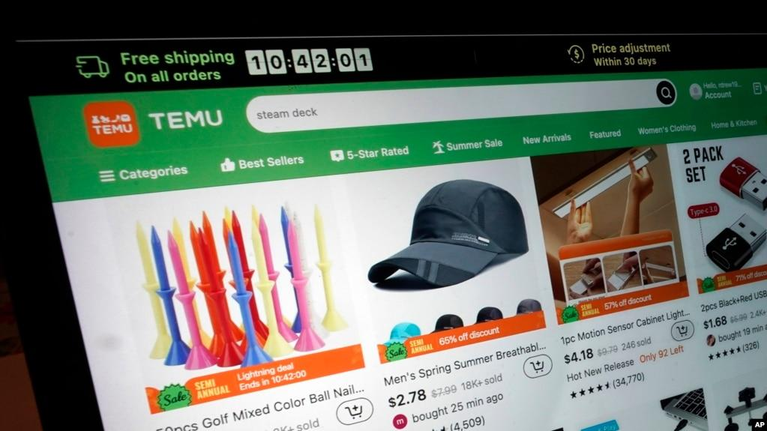

Seoul —
Women's accessories sold by some of the world's most popular online shopping firms contained toxic substances sometimes hundreds of times above acceptable levels, authorities in Seoul said Wednesday.
Chinese giants including Shein, Temu and AliExpress have skyrocketed in global popularity in recent years, offering a vast selection of trendy clothes and accessories at stunningly low prices that has helped them take on U.S. titan Amazon.
The explosive growth has led to increased scrutiny of their business practices and safety standards, including in the European Union and South Korea, where Seoul officials have been conducting weekly inspections of items sold by online platforms.
In the most recent inspection, 144 products from Shein, AliExpress and Temu were tested, and multiple products from all companies failed to meet legal standards.
Shoes from Shein were found to contain significantly high levels of phthalates — chemicals used to make plastics more flexible — with one pair 229 times above the legal limit.
"Phthalate-based plasticizers affect reproductive functions such as sperm count reduction, and can cause infertility and even premature birth," an official from Seoul's environmental health team told AFP.
One such chemical "is classified as a human carcinogen by the International Cancer Institute, so special care should be taken to avoid long-term contact with the human body," they added.
Formaldehyde, a chemical commonly used in home building products, was detected in Shein's caps at double the allowable threshold.
Two bottles of nail polish from Shein were found to have dioxane — a possible human carcinogen that can cause liver poisoning -- at levels more than 3.6 times the allowed limit and methanol concentrations 1.4 times above the acceptable level.
Lead in sandals
Shein told AFP that they "work closely with international third-party testing agencies... to regularly carry out risk-based sampling tests to ensure that products provided by suppliers meet Shein's product safety standards."
"Our suppliers are required to comply with the controls and standards we have put in place as well as the product safety laws and regulations in the countries we operate in," the company added.
Seoul authorities found sandals from Temu contained lead in the insoles at levels more than 11 times the permissible limit.
"Upon receiving notice from the Seoul city government, we immediately launched an internal investigation," a spokesperson from Temu told AFP.
"We have swiftly removed these product listings from our global marketplace and are enhancing our systems and guidance to merchants to ensure they comply with safety standards and local regulations."
Seoul officials asked for all the products to be removed from sale, according to a government statement.
"Products that exceed the legal limit are products that directly contact the body, such as leather sandals and hats, so citizens should pay special attention," said Kim Tae-hee, an official in the capital.
"The Seoul Metropolitan Government will continue to conduct safety tests periodically and disclose the results."
The European Union in April added Shein to its list of digital firms that are big enough to come under stricter safety rules — including measures to protect customers from unsafe products, especially those that could be harmful to minors.

